Programming a Web App for Patients Suffering from Fatigue

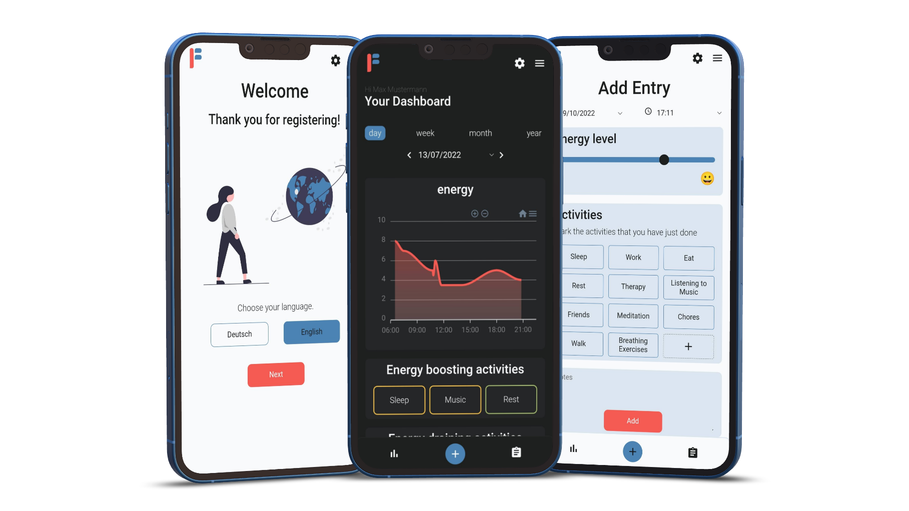

Jon Jampen

Ralf Kretzschmar

B19a

Kantonsschule Solothurn

2022

By

Supervisor

Class

School

Year

# Abstract

Fatigue patients often keep track of their energy level on a paper chart to plan their day and schedule enough rest time. The goal of this project was to find out whether I can create a web app that makes it more comfortable to use than the chart on paper. My web app allows users to enter their energy level after every activity and to display different charts showing the energy level throughout the day, week, month, or year. Additionally, the web app rates the activities based on their impact on the energy level which is calculated using all the user’s entered data from the past month. The web app was tested by about 15 therapists who were referred to me by my therapist and about as many patients who found my web app on social media. The few feedbacks I received from therapists and patients, as well as my own experience show that the web app offers a more efficient and practical way of tracking one’s energy.

# Preface

## Motivation

I have suffered from chronic fatigue syndrome caused by COVID-19 since November 2020. In therapy I had to fill out charts on a piece of paper to learn the pacing method. I wanted to get rid of the growing stack of paper and provide a better organized solution. Nowadays I think there should be a way to do that digitally. So, I wanted to create a web app as an alternative to those charts. It was also my intention to use the entered data to provide better analysis than just one chart.

## Acknowledgement

I thank Kathrin Hofer (dipl. occupational therapist at the Bürgerspital Solothurn) for connecting me with therapists and patients who tested the web app, Thomas Jampen for providing me with a webserver, Noe Emch and Tobias Yoong for testing my web app for bugs, and everyone else who tested the web app and sent me feedback. I also thank Ralf Kretzschmar for supervising my project.

Table of Contents

Abstract 2

Preface 2

Motivation 2

Acknowledgement 2

1. Introduction 4

1.1 Fatigue 4

1.2 Chronic Fatigue Syndrome 4

1.3 Pacing 4

1.4 Project Idea 5

2. Process 6

3. Web App 7

4. Programming 9

4.1 Languages and Technologies 9

4.1.1 Website 9

4.1.2 Git and GitHub 9

4.1.3 Database 10

4.1.4 Progressive Web Application (PWA) 10

4.2 Folder Structure 11

4.3 Libraries 11

5. Conclusion 13

6. Figures 14

7. Sources and Bibliography 14

8. Appendix 16

8.1 Energieprofil 16

8.2 Mockups Version 1 17

8.3 Mockups Version 2 18

9. Feedback Forms 20

# Introduction

## Fatigue

Fatigue is a symptom that appears in several illnesses, however there are two types of fatigue: the one that improves with physical and mental activity and the one that gets worse if a patient does too much exertion. The former form appears for example in cancer patients whereas the latter version is common in illnesses like chronic fatigue syndrome or multiple sclerosis. There is no treatment or cure for the second form of fatigue. Every exertion can make it worse therefore pacing (see below) is a big part of minimizing symptoms. For this paper I am going to focus on chronic fatigue syndrome (CFS).

Fatigue is often used as a synonym for tiredness however those two terms are significantly different. Tiredness is something that everyone feels after an exhausting activity or day, but it is relieved by sleep. On the other hand, fatigue is constantly present and does not go away with sleep. [1]

## Chronic Fatigue Syndrome

The Centers for Disease Control and Prevention (CDC) [2] describe CFS as an illness with no cure. People living with it are often extremely limited in what they are able to do compared to before getting CFS. Managing their day-to-day life can be incredibly challenging since any physical or cognitive activity can worsen one’s symptoms. This worsening of symptoms is known as post-exertional malaise (PEM) or often called a “crash”. Sometimes symptoms worsen immediately after the activity but occasionally it takes up to 48 hours. PEM can cause people to become housebound or even bedridden. Even though fatigue will not go away completely, resting is important to improve the symptoms and to prevent from getting a crash.

Apart from severe fatigue and PEM other symptoms might be sleep problems, difficulties with thinking (often called “brain fog”), headaches, muscle pain, and many more.

According to the CDC, it is not yet clear what causes CFS, but some assumptions are that it could be caused by a viral infection (like the Epstein-Barr or SARS-CoV-2 virus) or a change in the immune system. Scientists suppose that it could be genetically inheritable.

## Pacing

Pacing is a strategy that fatigue patients use to manage their symptoms. The goal of pacing is to plan the day in a way that it does not cause a “crash”. This means that patients need to learn how to spend their energy so that it lasts for the entire day. To achieve that patients must plan a lot of rest time to recover. Making rest time as effective as possible is of essence, therefore one should understand what activities can help with gaining energy. However, that is just one of many aspects of pacing. Additionally, it is important to shorten activities or split them into several smaller parts. Furthermore, activities that drain a lot of energy must be avoided.

To teach this technique therapists often use printed charts (like the one created by H. Lorenzen [3], see Appendix 8.1). The idea of the chart is for the patient to write down what they have done and how bad their fatigue is afterwards. The y-axis describes the energy level (the energy level shows how much energy one has, therefore if the fatigue is bad, the energy level is low) while the x-axis represents time. Under the time axis there is space to write down what activities one has done at a certain time. The patient should now fill out this chart after every activity. This can help with understanding what activities drain a lot of energy and which activities help to regain some energy. Additionally, one may see that certain activities are better at one time than another or that at a certain time the energy is always quite low. With this information one can then plan the day better.

## Project Idea

The idea of this project is to create a digital and enhanced version of Lorenzen’s chart used in therapy. I decided to do it as a web app. That would present the following advantages. For one, the patients do not have to write everything down on paper but can do it on their phones that they have on them all the time. Furthermore, the entered data can be automatically analyzed and used for more than just one chart: It can be used to compare different days or month, or an algorithm can calculate what activities help with gaining energy and which drain energy.

Furthermore, a goal was for me to be able to use the digital version for myself to track my fatigue as well as let therapists try it out. If possible, I even wanted to get feedback from fatigue patients.

This leads to the question: Can a self-programmed web app provide better support for fatigue patients than the paper forms currently used in therapy?

# Process

I started with sketching simple mockups (see Appendix 8.2) using Figma [4] to find out what elements I needed and how the user should be able to enter their data. I then programmed the basic functionality, which was signing up and logging in, creating activities, adding entries with an energy level and activities, and generating a chart displaying the energy levels throughout the day.

At this point I started learning about designing conventions like material design [5] so I can focus on a good-looking user interface. This helped me for example with choosing a primary and secondary color and made it easier to decide where to use which color. Afterwards I created new designs (see Appendix 8.3) based on what was working well and what was not, and I improved my code. Based on feedback from others, I additionally created a light theme which should be a bit more positive compared to the dark theme. I also implemented new features like a list with all the entries grouped in daily blocks, where the user can edit or delete an entry, as well as the possibility to switch between German and English, choose different time frames in the chart (week view, month view, and year view) and an automatic evaluation of what activities help with gaining energy and which drain energy.

Later I created an information page so that people can see what the web app does before they have to register. Additionally, I created a few onboarding screens that allow the user to set their preferences (like the language and the theme). Those preferences can be changed in the settings page at any time. To help the user understand how the app works, a guided tour starts after signing up, that shows the user around the app. Finally, I designed app preview posts that I published on social media and in fatigue forums in hope that someone with fatigue would test it. At a later point I also registered my domain on google search console. However, sadly the website does not yet appear at the top when doing a search.

# Web App

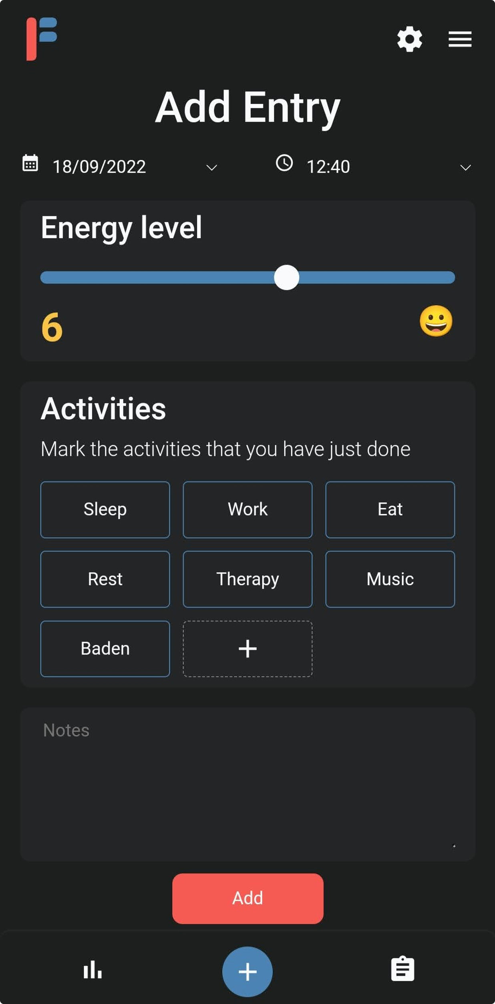

Figure : Screenshot of my web app showing the screen to add new entries.

I decided to do the project as a web application (or web app). A web app is available through a browser. However, unlike a website it does not just provide information, but it allows the user to interact with it. In contrast to mobile applications, web apps have the advantage that they are accessible from any device and operating system. Since the most used devices will be mobile phones, I designed the web app “mobile first” which means that the design is optimized for mobile devices. Nevertheless, I wanted to provide the possibility to download the web app to the user’s device, therefore I turned it into a progressive web app (see 4.1.4).

To help the users understand how the web app works, they are greeted with a few onboarding screens that help them set their preferences followed by a guided tour that shows them around the web app.

The web app allows users to create entries as you can see in Figure 1. Just like in the chart by H. Lorenzen one entry should be created after every activity. These entries contain the current energy level, the activities one has just finished, as well as some optional notes and a date and time. To help the user decide on an energy level there is an emoji and a color that adjust, depending on what level is entered. Every user can create their own activities.

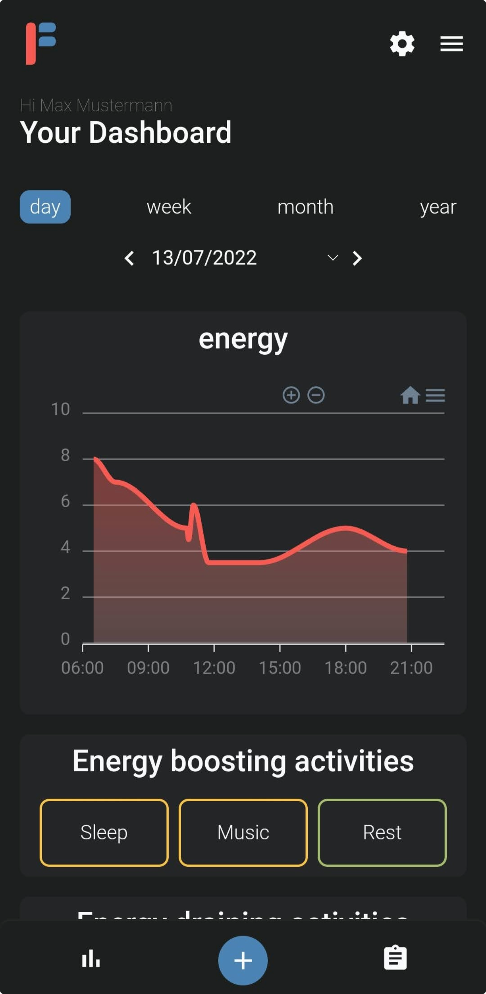

Figure : Screenshot of my web app showing the dashboard screen with the chart of the energy level throughout the day and the calculated activities.

Figure 2 shows the dashboard screen where charts based on the entered data are shown. For one the user can see their energy throughout the day. The date can be changed, and the user can also select another timeframe like a week, month, or year view. This allows the user to compare days or months with eachother.

Below the chart, the activities are evaluated into two categories: the energy boosting and the draining activities. The value for every activity is calculated using the data form the past 30 days. It has to be noted, that only the direct impact of the activity on the user’s energy level is considered which means that late effects of PEM are ignored. Activities, that on average have a positive influence are displayed in descending order. Every activity has one of three colors. The best activity always has a green color, whereas the one with the least positive impact is yellow. The other activities are colored with one of the three colors depending on their impact. The same follows for the energy draining activities using red as the color for the activity with the worst impact.

Users can edit or delete their entries, which is also an improvement to the paper version. On the list view one can see every entry from the past seven days grouped in daily blocks. Every day has an average however the calculation is not as easy as the arithmetic mean. If it were just the arithmetic mean, time would not have an influence. However, as the following example shows, time is important in this calculation. As Figure 3 shows, the energy level starts at ten and ends at five in both charts, the difference is that the energy level in the chart on the left goes down to five earlier than in the one on the right.

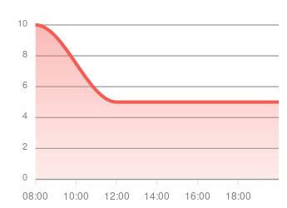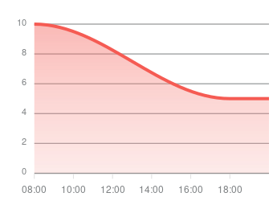

Figure : Two charts showing the energy level throughout the day. In the left one the energy level goes down to 5 at 12pm already whereas in the right chart it goes down to 5 at 6pm.

The arithmetic mean would be the same for both ($\overline{x}=\frac{10+5+5}{3}=6.67$) but clearly the day on the right is significantly better than the one on the left. Therefore, time needs to be included. I decided to calculate the arithmetic mean $\overline{x}$ between two entries and then use the following formula, so that the average is weighted depending on the time $∆t$ in minutes between those two entries: $value= \frac{\overline{x} * ∆t}{t_{total}}$. Doing this for every two entries and adding up all values results in the average used for this project. Using this formula in the example above results in an average of $5.8$ in the left chart compared to a $7.1$ in the chart on the right.

# Programming

## Languages and Technologies

### Website

The web app is created using HTML [6] for the structure of the website, CSS [7] for styling it, and JavaScript [8] for its interactivity. As a backend language I used PHP [9] which generates the HTML pages on the server.

### Git and GitHub

For this project I learned about the version control system Git [10]. Git is the standard tool for version control and collaborative work used by a lot of small teams as well as big companies. It also serves in a way as a backup since one can go back to any desired version at any time. Additionally, it can be used to compare the current code with the one from a previous version. This helps to resolve errors that did not appear in a previous version.

As shown in Figure 4 I used several feature branches which I tested on my laptop using XAMPP [11] (a development environment) with an Apache server. After testing a certain feature, I merged the corresponding feature branch into the development branch.

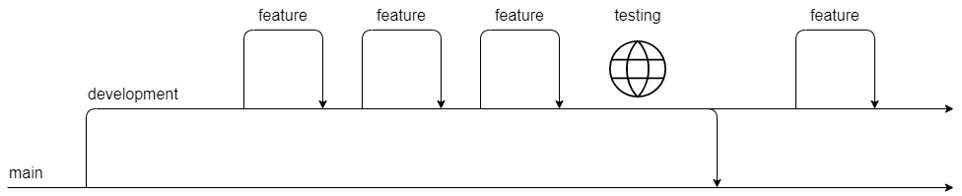

Figure : Structure of my workflow using several branches in Git.

The web server was linked to GitHub [12] and set up with automatic deployment. This means that as soon as I pushed the development branch to GitHub, the testing website (<https://dev.fatiguediary.ch/>) was automatically updated to that version. If everything worked on the test site, I merged the development branch into the main branch which automatically updates the web app if there is a new commit pushed.

### Database

I used a MySQL [13] database to store the user’s data. Figure 5 illustrates the database structures and the connection between its tables. One of the tables is the users table, where the username, email address and an encrypted password is stored. Every user has a unique user ID. This ID is used to link rows from other tables to a user. The energy table contains the energy level, notes and the date of every entry that is created. User’s activities are stored in the activities table. The energy_activity table is a connector between the energy and the activity table. It contains the ID of the entry and the ID of the activity. For every activity that a user attaches to an entry a new row in energy_activity is created. The resettoken table is used to create tokens (a long string of random characters that is difficult to guess) for resetting the password securely. The same applies for the tokens table with the difference that those tokens are used to keep the user logged in so that one does not have to log in every time when reopening the web app. Settings is a table used to store the preferences the user decides to set.

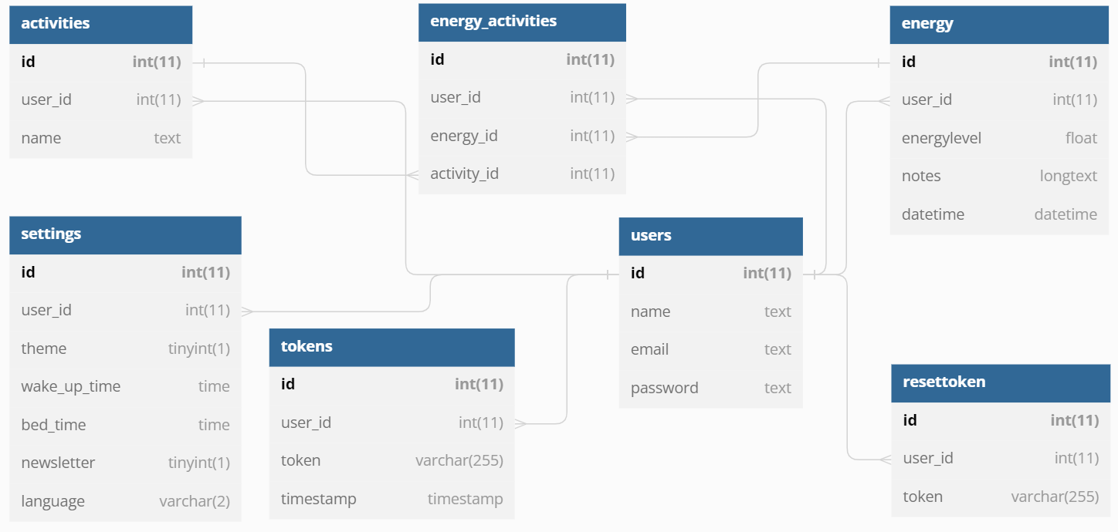

Figure : Structure describing my database setup. The lines connect entities that are the same in several tables. Graphic created with dbdiagram.io [19].

### Progressive Web Application (PWA)

To allow the user to download the web app to their device I turned it into a progressive web application (PWA) [14]. PWAs can be installed on any device using a browser. Once installed the website opens in a standalone window instead of the browser window. This means that elements like the search bar of the browser are hidden, and the web app can take up as much space as possible. In addition, it gives the user the feeling of using a native app.

## Folder Structure

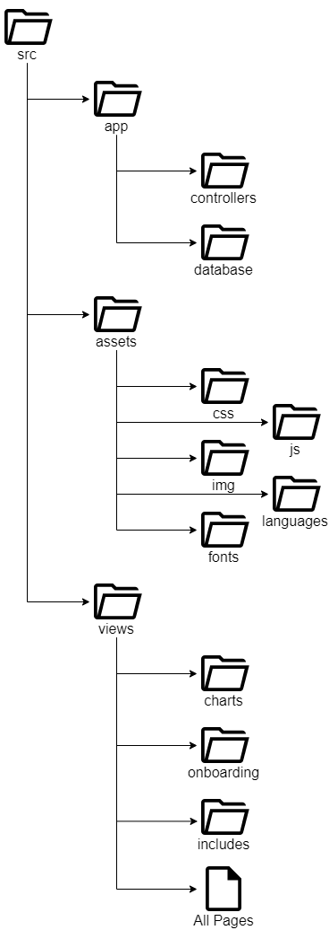

Figure : Folder structure of the code in my project.

My code is structured into several folders as displayed in Figure 6. The app folder contains everything from the backend while the views folder contains mostly the frontend for pages including the dashboard and the onboarding screens. In the assets folder I put for example the CSS and JavaScript code, images, and language files. A few files are in the root directory. That includes the index file, the manifest (used to provide the PWA with information), the service worker (also used for the PWA) and the sitemap for google search. They all have to be put into the root directory for the web app to function properly.

## Libraries

After using chart.js [15] in the beta-version of my web app I decided to switch to Apexcharts [16]. Mostly because I preferred the style of Apexcharts and the tooltip in Apexcharts is more user friendly. A tooltip is a box that appears when the user clicks on the chart. It displays more information about the point on the graph that the user clicked on. With chart.js the user had to press exactly on the point, whereas with Apexcharts the user can just click anywhere on the chart, and it opens the tooltip for the closest point.

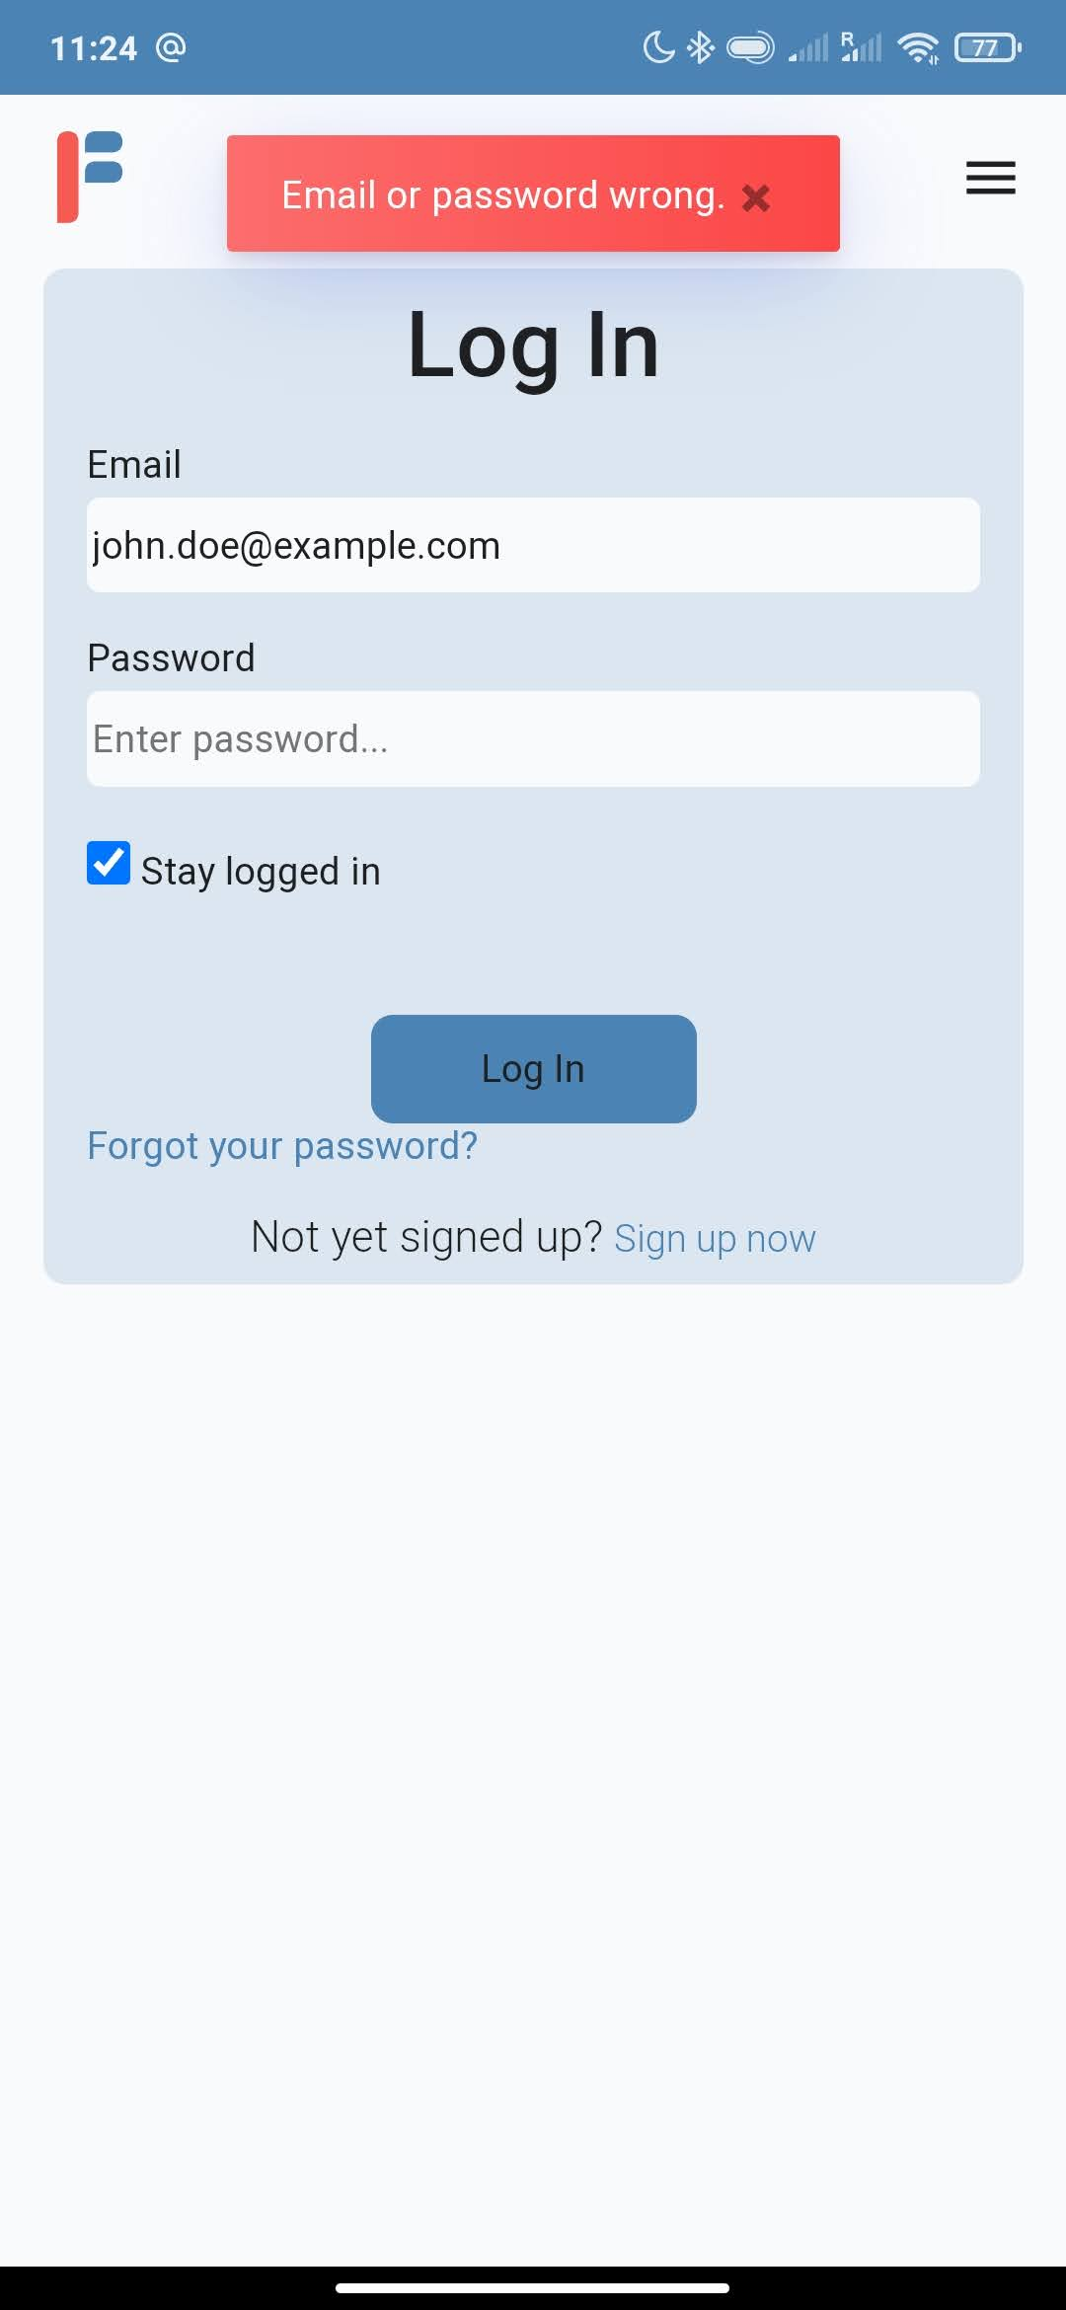

Figure : Screenshot of my web app showing an error message from the Toastify library.

To improve the user experience, I used Toastify [17] which displays success or error messages. For example, like in Figure 7 when logging in, but also when creating a new entry or changing the settings.

For creating a guided tour of my web app, I decided to use Shepherd after trying to use several other tools. It displays popup messages that point on one element of the screen. Sadly, it did not work as I hoped it would since Shepherd had a problem with handling input fields. The error was already stated as an issue on their GitHub page, however no one has found a solution yet. Therefore, I had to use a less optimal method and download the static version of my web app. I then disabled all input fields and used these files for the tutorial. Since it is static now, I had to create two versions, one in English and one in German.

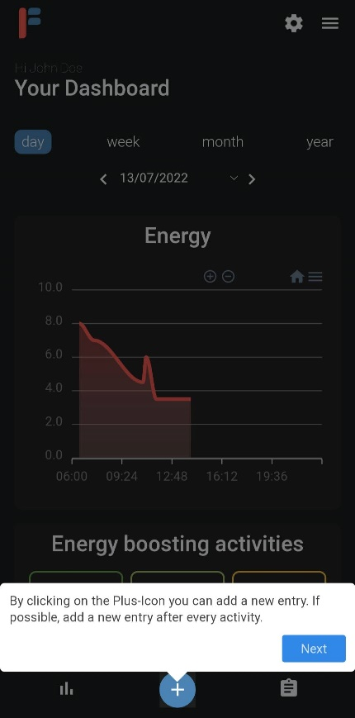

Figure : Screenshot of my web app showing the tutorial created with Shepherd.

# Conclusion

After using the web app daily for several months, I think that it is indeed more practical and faster to keep track of the energy levels than with the paper version. Additionally, the web app proved the findings we discovered in therapy (like for example what activities are draining a lot of my energy and what times of the day are usually better) but also provided more analyses.

I had about 15 therapists who voluntarily decided to test the web app. At first, I received a lot of feedback about what additional features would be helpful (like a symptom tacker or a way to enter the sleep quality). However, these features just didn’t fit into the schedule of a matura project. Sadly, I barely received feedback about the current features and whether they are helpful. Additionally, it was also difficult for therapists to find fatigue patients in such a short time who would be able and willing to try an app to see if it is helpful in therapy. Therefore, almost all patients who tested my app came from social media where I posted information about my web app.

Yet, the few comments I received were positive. One patient wrote in an email to me: “found your app today, loving it so far! just what i need to keep track of my fatigue caused by my ms.”. A therapist stated in the feedback: “The app can certainly not be useful for all patients, but still appeal to some and I think the idea is great! Thank you [translated from German by Jon Jampen]”. I of course knew from the beginning that not everyone would be comfortable using an app, for instance, elderly people who do not use their mobile phones that much.

In my opinion I completed my goal to create a web app that makes it easier to track one’s energy by creating a simplified way to learn pacing while also providing more analysis for the patients. There are still a lot of features that would be useful (like a symptom tacker and a way to enter the sleep quality) and maybe I will implement those features at a later point. https://github.com/shipshapecode/shepherd/issues/1143

# Figures

[Figure 1: Screenshot of my web app showing the screen to add new entries. 7](https://ksso-my.sharepoint.com/personal/u500782_ksso_ch/Documents/Maturaarbeit/Matura_Project_Jon_Jampen_x.docx#_Toc117947229)

[Figure 2: Screenshot of my web app showing the dashboard screen with the chart of the energy level throughout the day and the calculated activities. 7](https://ksso-my.sharepoint.com/personal/u500782_ksso_ch/Documents/Maturaarbeit/Matura_Project_Jon_Jampen_x.docx#_Toc117947230)

[Figure 3: Two charts showing the energy level throughout the day. In the left one the energy level goes down to 5 at 12pm already whereas to in the right chart it goes down 5 at 6pm. 8](https://ksso-my.sharepoint.com/personal/u500782_ksso_ch/Documents/Maturaarbeit/Matura_Project_Jon_Jampen_x.docx#_Toc117947231)

[Figure 4: Structure of my workflow using several branches in Git. 9](https://ksso-my.sharepoint.com/personal/u500782_ksso_ch/Documents/Maturaarbeit/Matura_Project_Jon_Jampen_x.docx#_Toc117947232)

[Figure 5: Structure describing my database setup. The lines connect entities that are the same in several tables. 10](https://ksso-my.sharepoint.com/personal/u500782_ksso_ch/Documents/Maturaarbeit/Matura_Project_Jon_Jampen_x.docx#_Toc117947233)

[Figure 6: Folder structure of the code in my project. 11](https://ksso-my.sharepoint.com/personal/u500782_ksso_ch/Documents/Maturaarbeit/Matura_Project_Jon_Jampen_x.docx#_Toc117947234)

[Figure 7: Screenshot of my web app showing an error message from the Toastify library. 12](https://ksso-my.sharepoint.com/personal/u500782_ksso_ch/Documents/Maturaarbeit/Matura_Project_Jon_Jampen_x.docx#_Toc117947235)

[Figure 8: Energieprofil nach H. Lorenzen. [3] 16](https://ksso-my.sharepoint.com/personal/u500782_ksso_ch/Documents/Maturaarbeit/Matura_Project_Jon_Jampen_x.docx#_Toc117947236)

[Figure 9: Version 1 of my mockups designed in Figma 17](https://ksso-my.sharepoint.com/personal/u500782_ksso_ch/Documents/Maturaarbeit/Matura_Project_Jon_Jampen_x.docx#_Toc117947237)

[Figure 10: Version 2 in light theme of my mockups designed in Figma. 18](https://ksso-my.sharepoint.com/personal/u500782_ksso_ch/Documents/Maturaarbeit/Matura_Project_Jon_Jampen_x.docx#_Toc117947238)

[Figure 11: Version 2 in dark theme of my mockups designed in Figma. 19](https://ksso-my.sharepoint.com/personal/u500782_ksso_ch/Documents/Maturaarbeit/Matura_Project_Jon_Jampen_x.docx#_Toc117947239)

# Sources and Bibliography

Project Link: <https://github.com/jonjampen/fatigue-diary>

|  |  |
| --- | --- |
| [1] | M. W. Smith, "WebMD," 8 December 2020. [Online]. Available: https://www.webmd.com/multiple-sclerosis/qa/what-is-the-difference-between-tiredness-and-fatigue#:~:text=Medically%20speaking%2C%20tiredness%20happens%20to,tiredness%20not%20relieved%20by%20sleep.. |
| [2] | Centers for Disease Control and Prevention, "Myalgic Encephalomyelitis/Chronic Fatigue Syndrome," 2022. [Online]. Available: https://www.cdc.gov/me-cfs/. [Accessed 16 September 2022]. |
| [3] | H. Lorenzen, «Tagesprotokoll zur Erstellung eines Energieprofils,» in *Fatigue Management*, 2nd Hrsg., Idstein, Schulz-Kirchner Verlag GmbH, 2022, p. 63. |
| [4] | "Figma," [Online]. Available: https://www.figma.com/. [Accessed 26 September 2022]. |
| [5] | "Material," [Online]. Available: https://material.io/design. [Accessed 26 September 2022]. |
| [6] | "HTML: HyperText Markup Language," 13 September 2022. [Online]. Available: https://developer.mozilla.org/en-US/docs/Web/HTML. [Accessed 26 September 2022]. |
| [7] | "CSS: Cascading Style Sheets," September 25 2022. [Online]. Available: https://developer.mozilla.org/en-US/docs/Web/CSS. [Accessed 26 September 2022]. |
| [8] | "JavaScript," 13 September 2022. [Online]. Available: https://developer.mozilla.org/en-US/docs/Web/JavaScript. [Accessed 26 September 2022]. |
| [9] | "php," 2022. [Online]. Available: https://www.php.net/. [Accessed 26 September 2022]. |
| [10] | "Git," [Online]. Available: https://git-scm.com/. [Accessed 15 October 2022]. |
| [11] | "XAMPP Installers and Downlaods for Apache Friends," [Online]. Available: https://www.apachefriends.org/. [Accessed 15 October 2022]. |
| [12] | "GitHub," [Online]. Available: https://github.com/. [Accessed 19 October 2022]. |
| [13] | "MySQL," [Online]. Available: https://www.mysql.com/. [Accessed 26 September 2022]. |
| [14] | "web.dev," [Online]. Available: https://web.dev/progressive-web-apps/. [Accessed 26 September 2022]. |
| [15] | "Chart.js," [Online]. Available: https://www.chartjs.org/. [Accessed 19 October 2022]. |
| [16] | "Apexcharts," [Online]. Available: https://www.cdc.gov/me-cfs/. [Accessed 16 September 2022]. |
| [17] | apvarun. [Online]. Available: https://apvarun.github.io/toastify-js/. [Accessed 26 September 2022]. |

# Appendix

## Energieprofil

Figure 9: Energieprofil nach H. Lorenzen. [3]

## Mockups Version 1

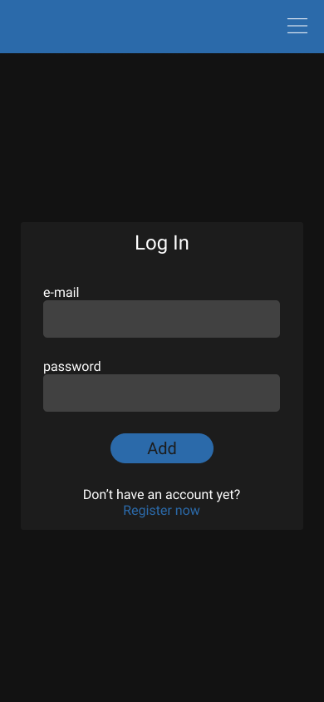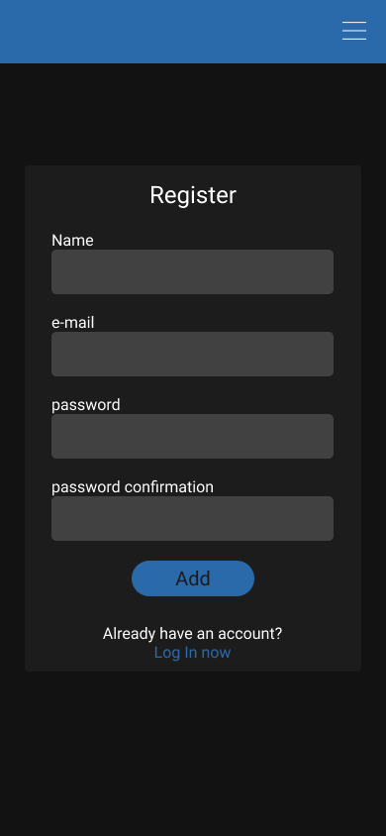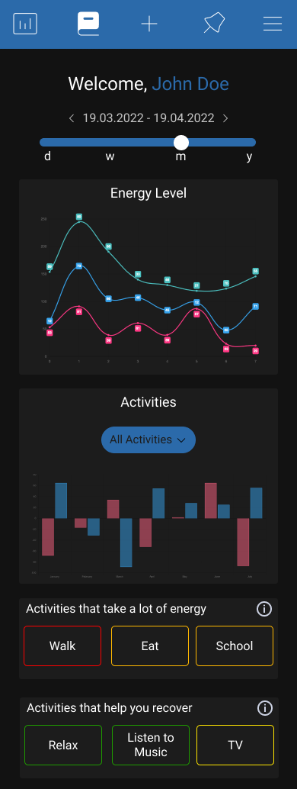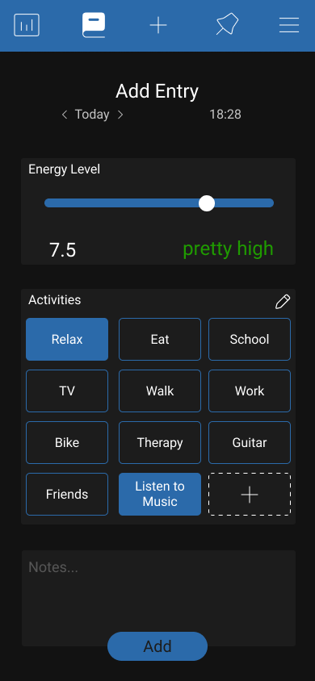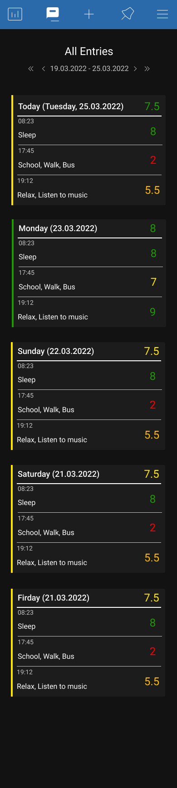

Figure 10: Version 1 of my mockups designed in Figma.

## Mockups Version 2

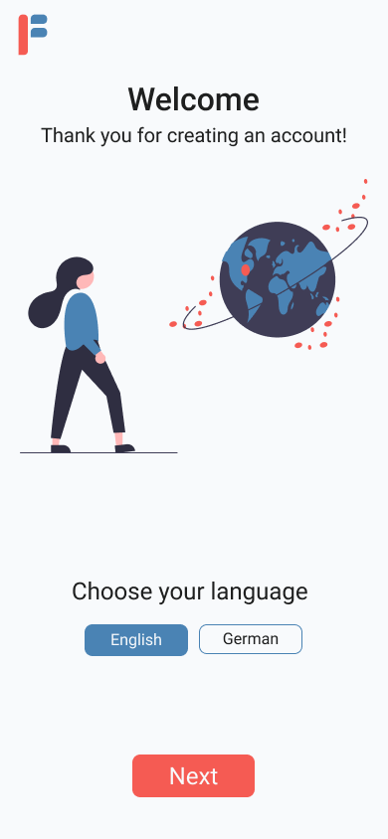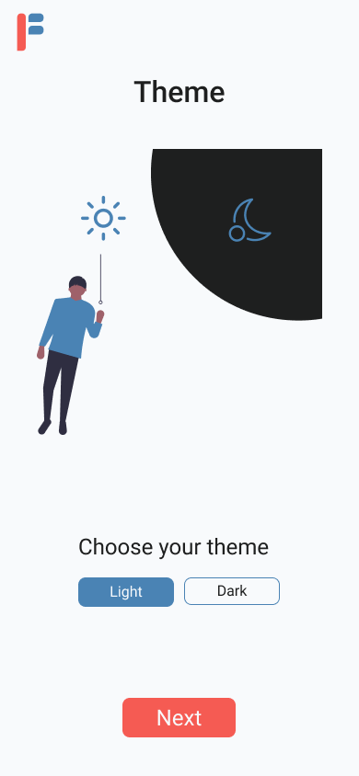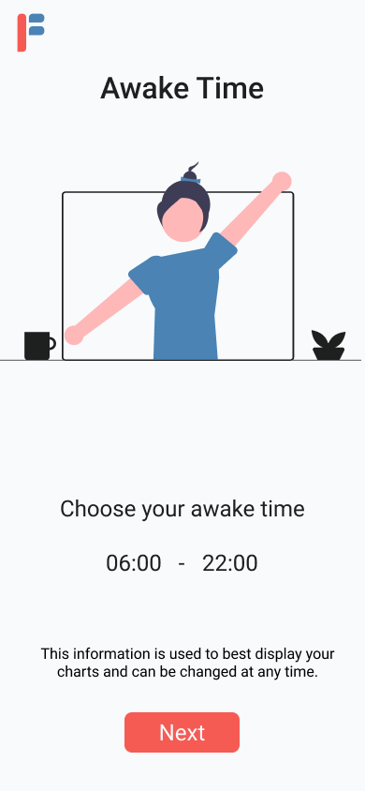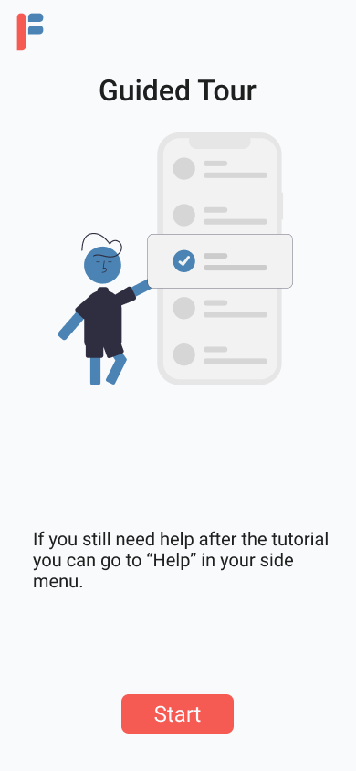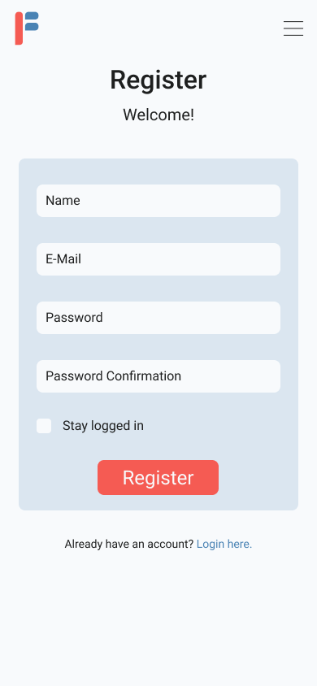

Figure 11: Version 2 in light theme of my mockups designed in Figma.

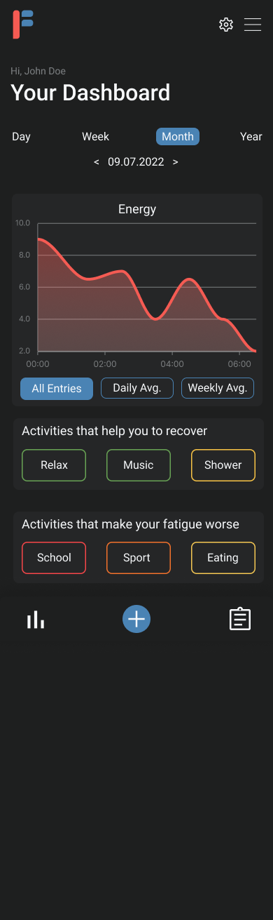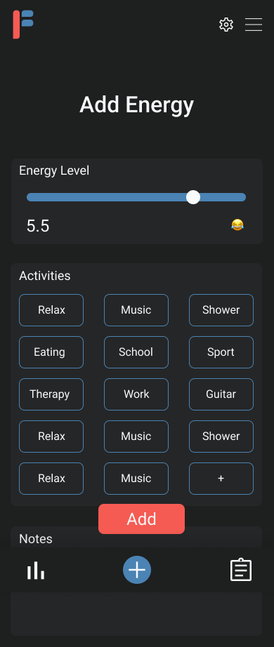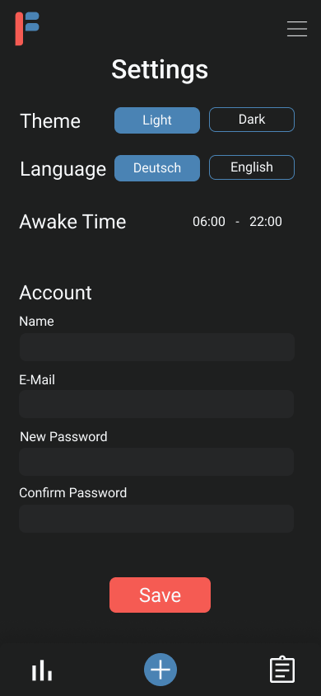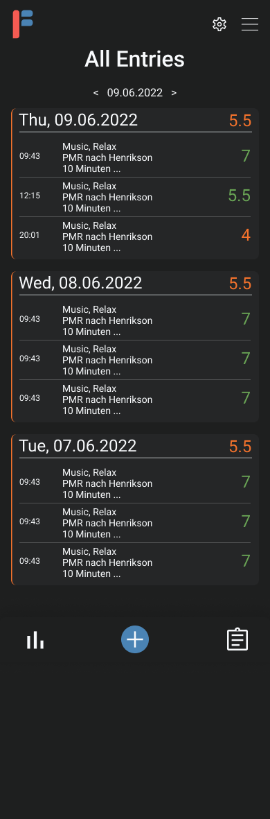

Figure 12: Version 2 in dark theme of my mockups designed in Figma.

# Feedback Forms